Data migration from Postgres (On-Premises) to RDS MySQL using AWS Data migration service.
Setting up and managing an RDS environment, covering the creation of security groups, RDS instances, and database migration tasks.
Connecting to RDS instances, executing database operations, creating replication instances in DMS, and setting up endpoints for RDS instances.
Created two Security Groups for RDS Instances
Created a RDS PostgreSQL Instance
Created a RDS MySQL Instance
Connecting to an Amazon PostgreSQL RDS Database on a DB Instance
Created a Replication Instance in DMS
Created a Source Endpoint in DMS
Created a Target Endpoint in DMS
Created a Database Migration Task
Connected to an Amazon MySQL RDS Database on a DB Instance

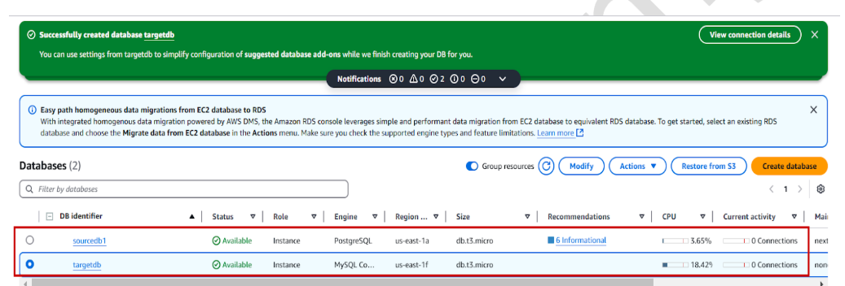

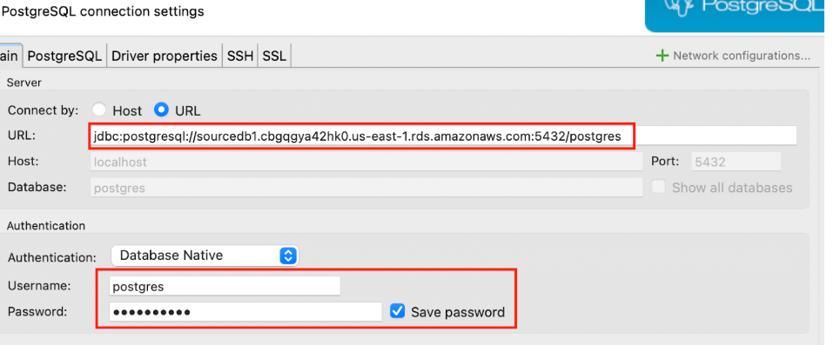
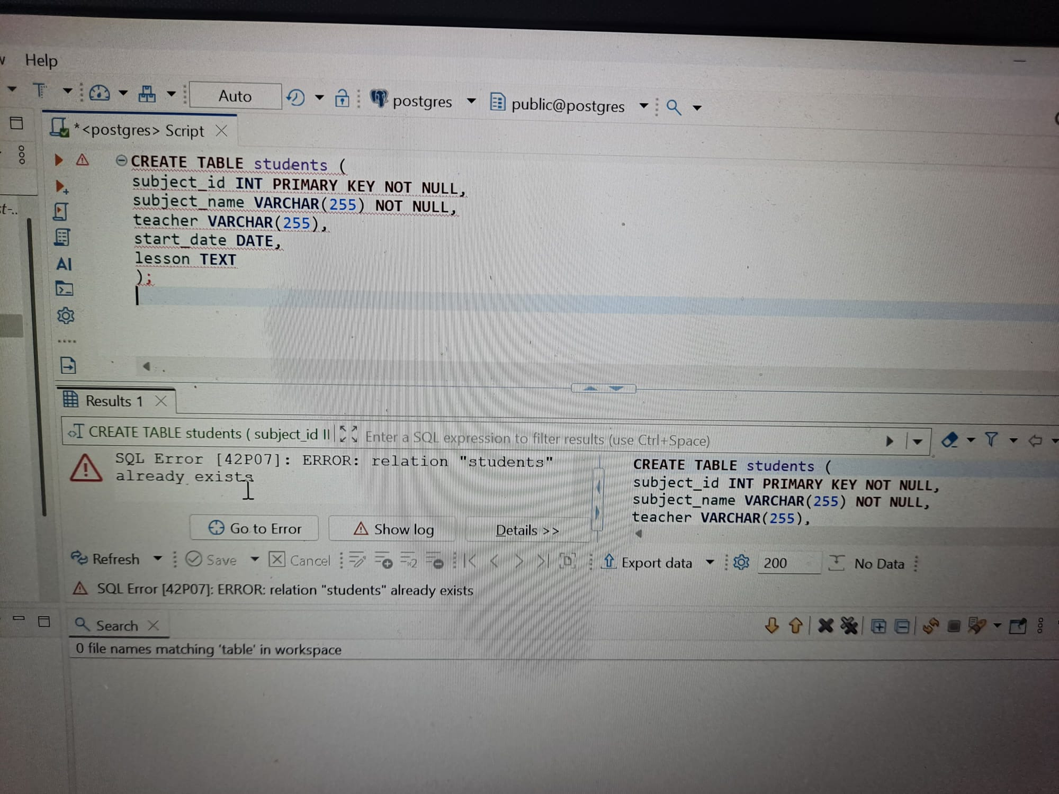

Troubleshoot the error and created a table (students ) .

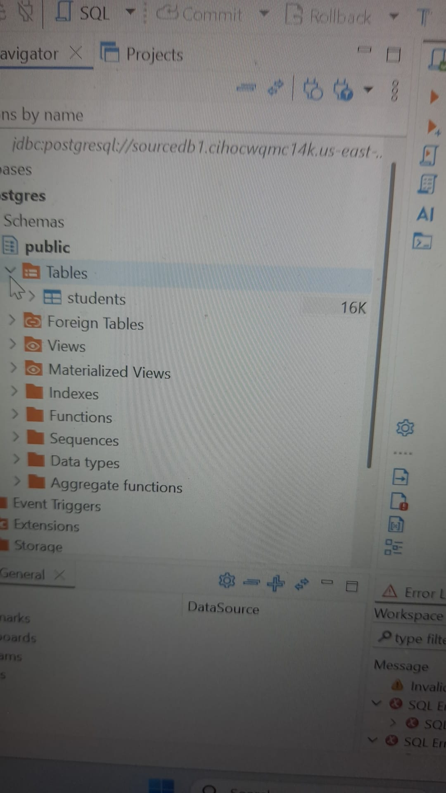
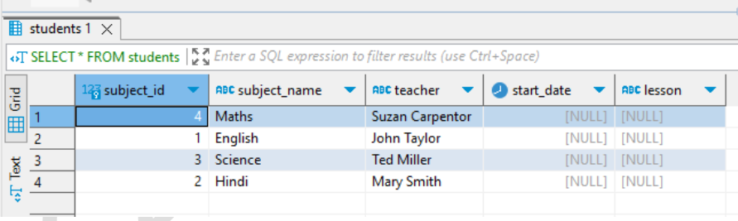
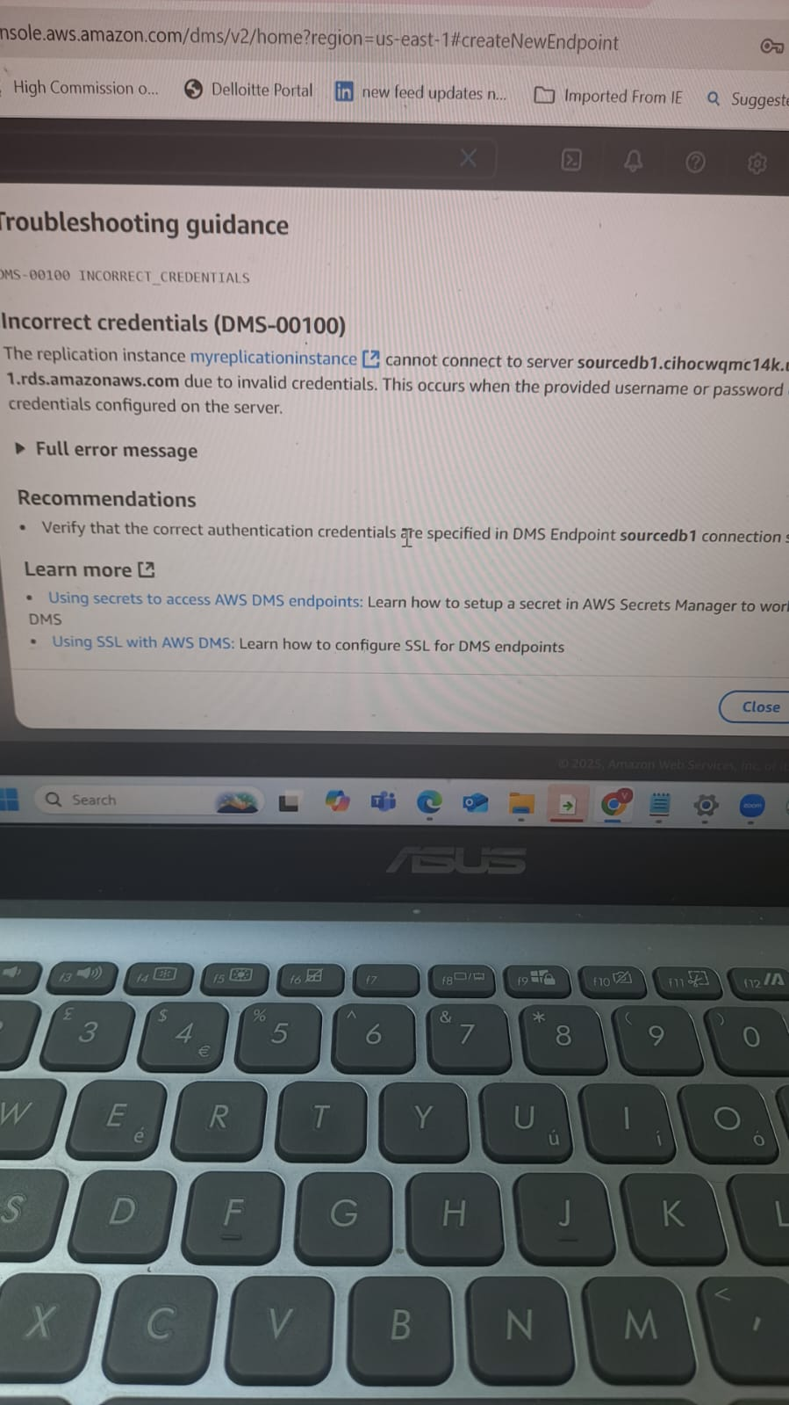
Troubleshoot the error which was not due to wrong credentials but because of SSL layer supported by Postgres SQL.

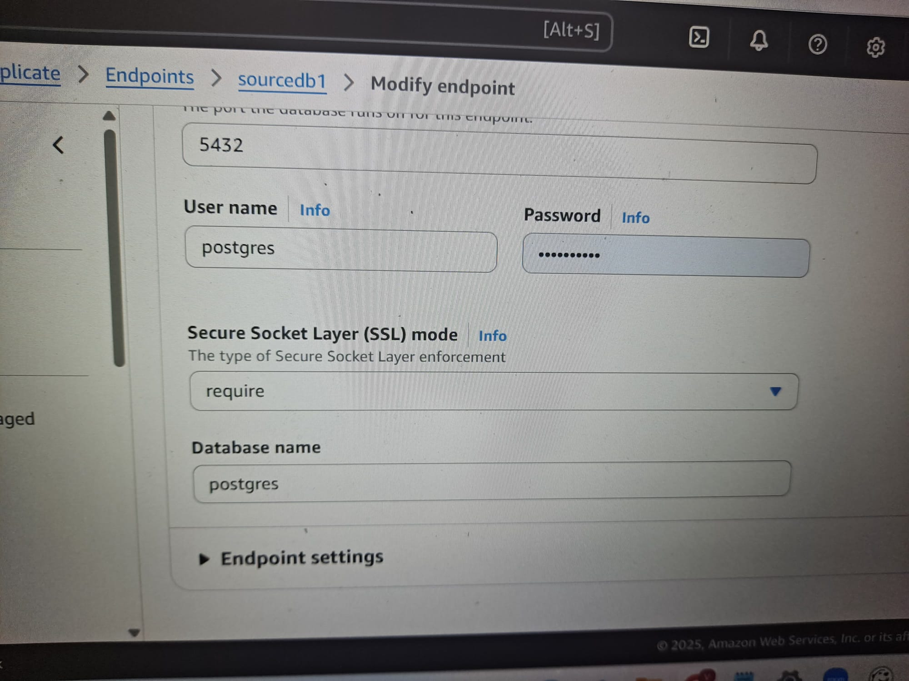

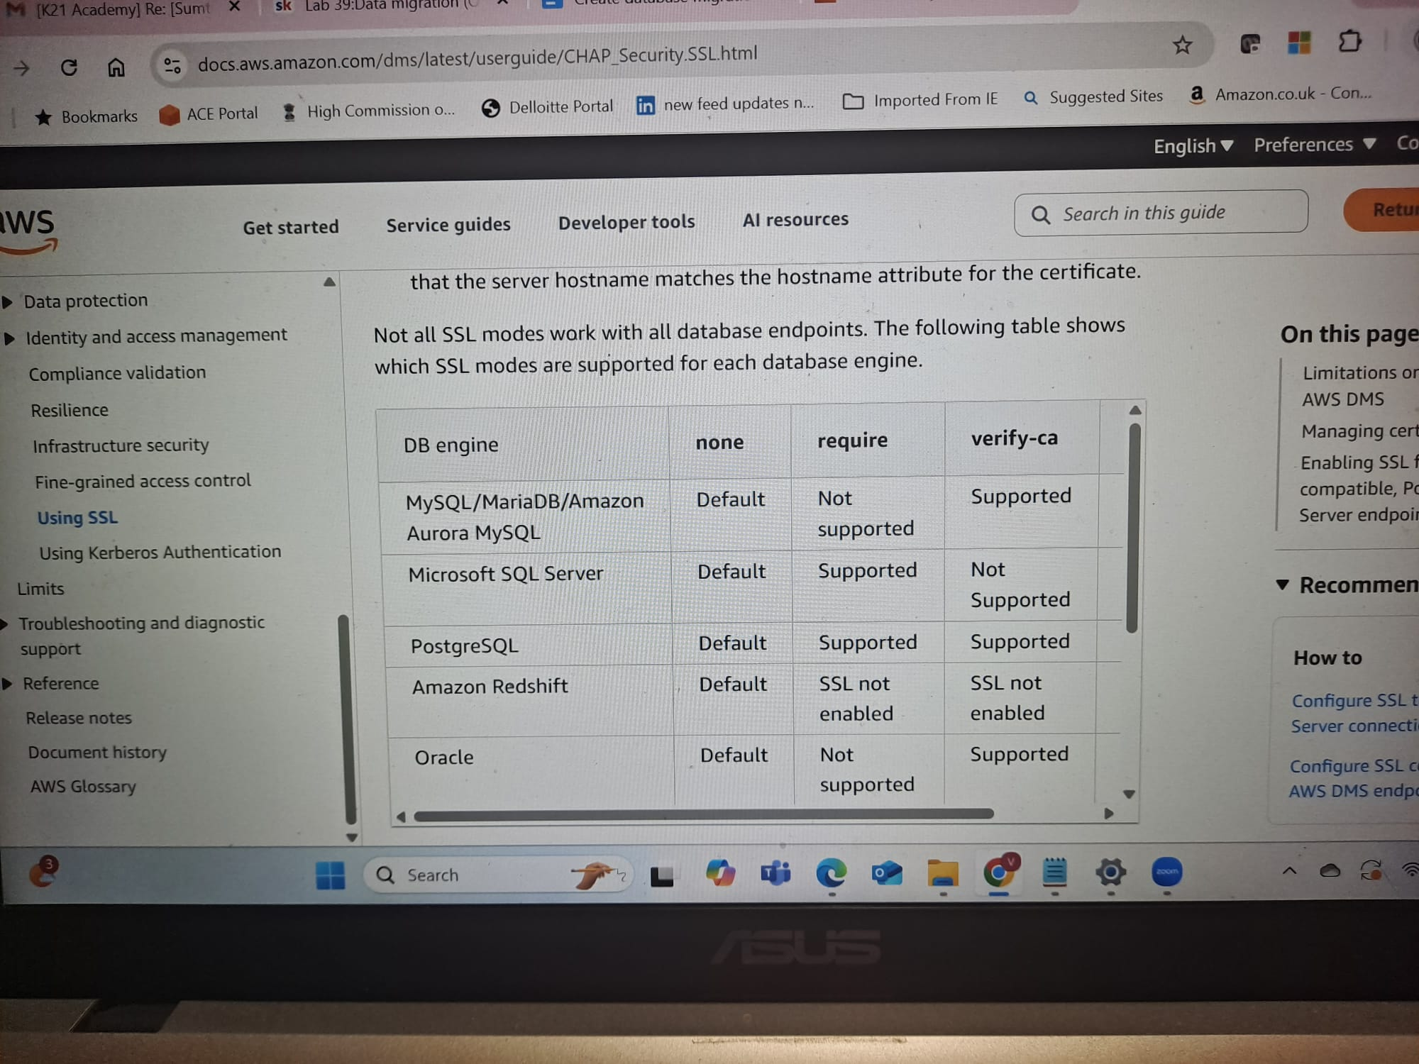

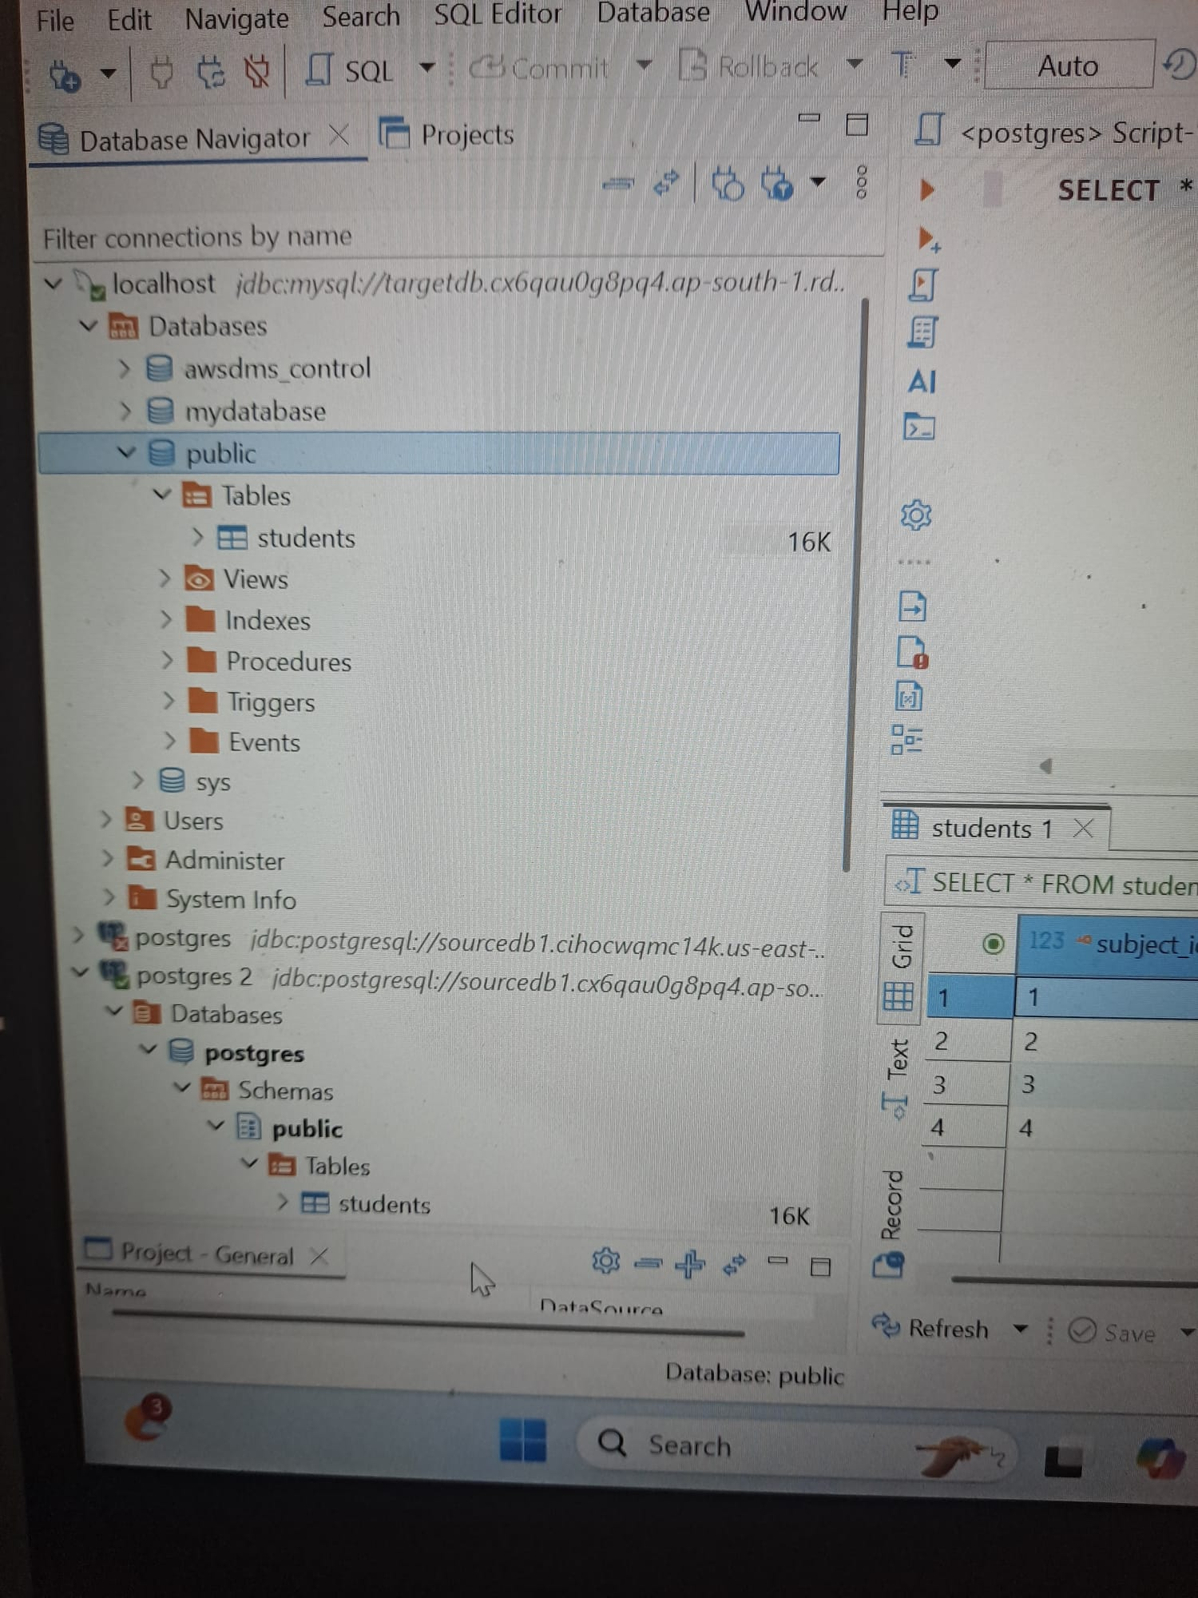

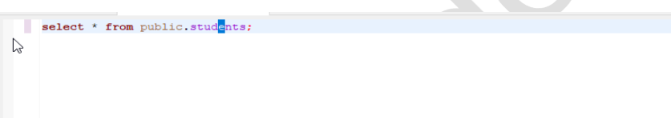
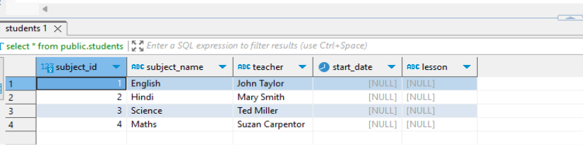

Successfully migrated the data from on premises Postgres SQL to MySQL on AWS.

